Stage 4
Mixed Selection 2 – Solutions

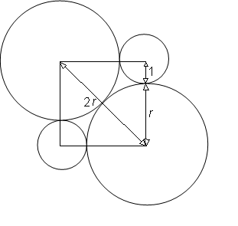
- Centre square
Let r be the radius of each of the larger circles.
The sides of the square are equal to $r+1$, the sum of the two radii.
The diagonal of the square is $2r$.
By Pythagoras, ${\text{(r+1)}}^{\text{2}}\text{+}{\text{(r+1)}}^{\text{2}} \text{=}{ \text{(2r)}}^{\text{2}}$
Simplifying gives: ${\text{(r+1)}}^{\text{2}} \text{=} \text{2}{\text{r}}^{\text{2}}$
so $\text{r+1} \text{=} \sqrt{\text{2}}\text{r}$
Therefore $\text{(}\sqrt{\text{2}}\text{-1)r} \text{=} \text{1}$
Hence $\text{r} \text{=} \frac{\text{1}}{\sqrt{\text{2}}\text{-1}} \text{=} \sqrt{\text{2}}\text{+1}$
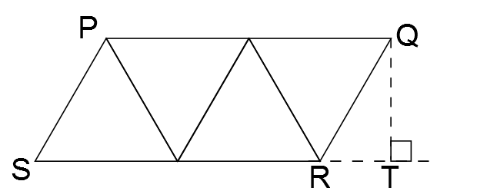
- Crane arm
In the diagram, T is the foot of the perpendicular from Q to the extension of SR. All of the angles in the equilateral triangles are 60°, so ∠QRT is also 60°. Then ΔQRT is a right-angled triangle, so using trigonometry we can show that the lengths of RT and QT are $\frac{1}{2}$ and $3\sqrt{2}$ respectively.
Applying Pythagoras' Theorem to ΔQST,
$${SQ}^{2}={ST}^{2}+{QT}^{2}=5^{2}+{\left(\sqrt{3}\right)}^{2}=25+3=28$$
So the length of SQ is $\sqrt{28}=2\sqrt{7}$ units.

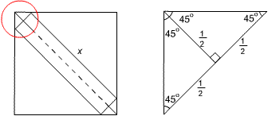
- Walk the plank
The figure shows the top left-hand corner of the complete diagram. Note the symmetry which leads to the three measurements of $\frac{1}{2}$. Thus the diagonal of the square can be divided into three portions of lengths:
$\frac{1}{2}, x$ and $\frac{1}{2}$ respectively.
The length of the diagonal is $\sqrt{{10}^{2}+{10}^{2}}=\sqrt{200}=10\sqrt{2}$
So $x=10\sqrt{2}-1$.

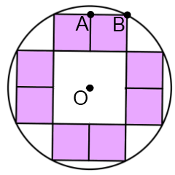
- Indigo interior
Let the centre of the circle be O and let A and B be corners of one of the shaded squares, as shown.
The circle has area $π$ square units, so OB is 1 unit long.
Let the length of the side of each of the shaded squares be x units.
By Pythagoras,${\text{OB}}^{\text{2}}\text{=}{\text{OA}}^{\text{2}}\text{+}{\text{AB}}^{\text{2}}\text{; that is} {\text{1}}^{\text{2}}\text{=}{\text{(}\text{2}\text{x}\text{)}}^{\text{2}}\text{+}{\text{x}}^{\text{2}}$.
So $\text{5}{\text{x}}^{\text{2}}\text{=1}$.
Now the total shaded area is $8x^{2}=\frac{8}{5}$ square units.

